Physical Appearance
Character
Relationship to Others

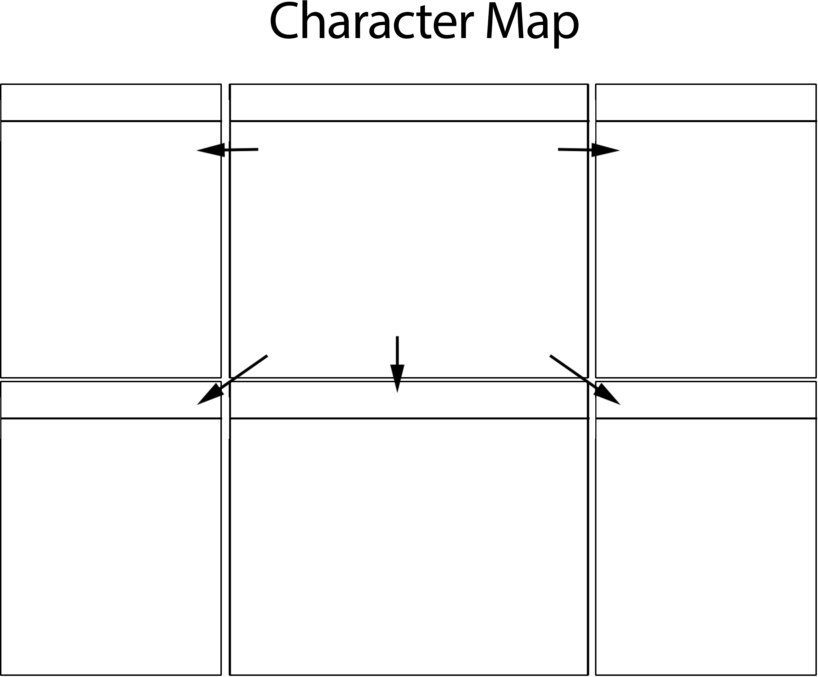
Personality Changes Over Time
Memorable Quotes

